# **Install Tomcat Windows**

**Steps To Install Tomcat For Windows:**

1. Download latest Tomcat from <https://tomcat.apache.org/download-90.cgi>

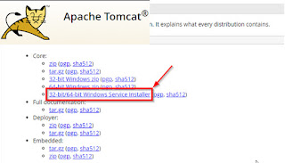

1. Before run the Tomcat installer, make sure you already installed OpenJDK.
2. Open Tomcat installer. Click Yes.

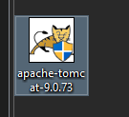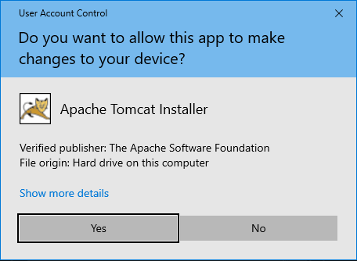

1. Click "Next".

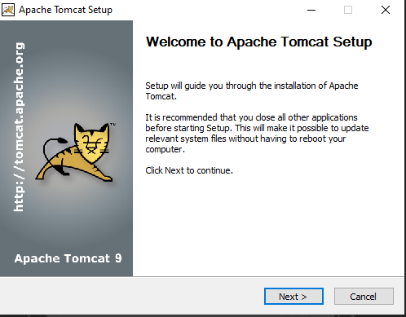

1. Click "I Agree".

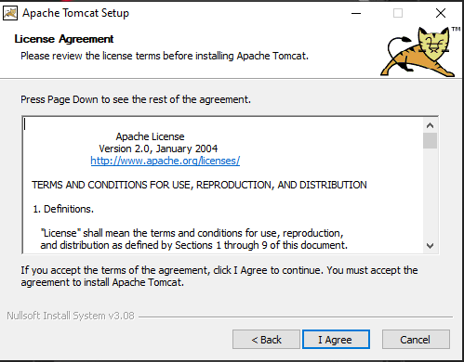

1. Change the settings based on what you preferred. Click "Next" after that.

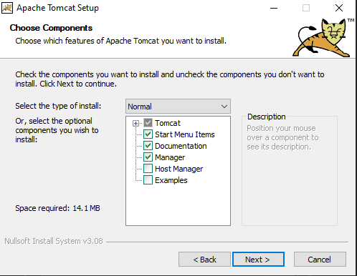

1. Change the settings based on what you preferred. Click "Next" after that.

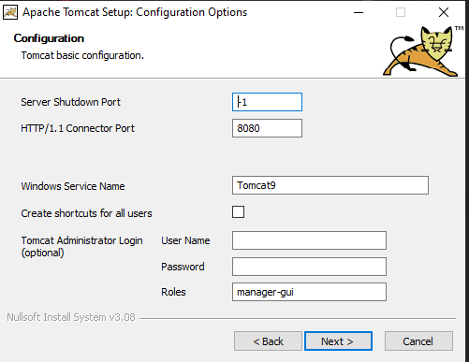

1. Choose your OpenJDK or JRE folder. After that, click "Next".

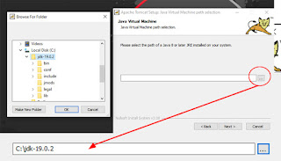

1. Click "Install".

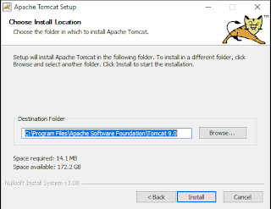

1. Wait until it finished.

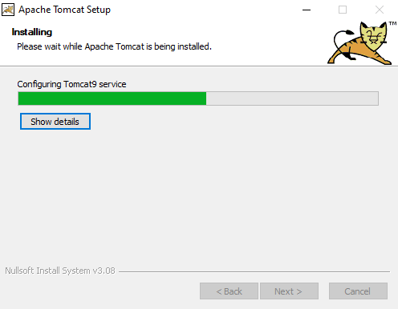

1. Click "Finish".

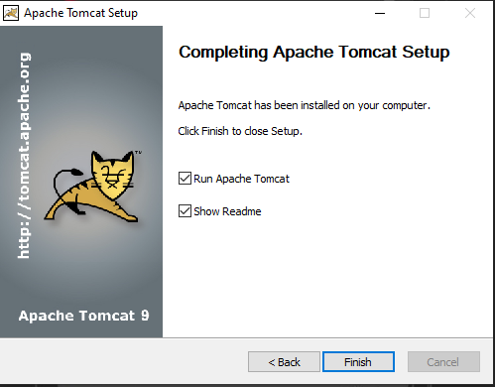

1. Open "Services" and make sure Tomcat service is run.

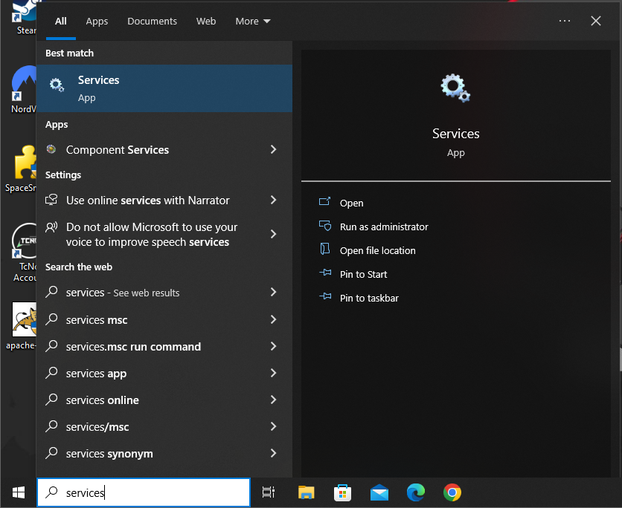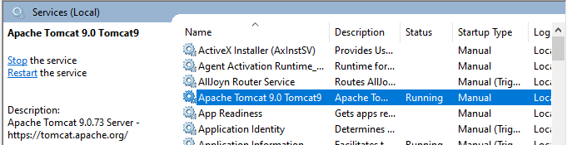

1. Run Tomcat page to make sure that the Tomcat installation is installed correctly and perfectly. Use this link to open Tomcat page http://localhost:8080/ .

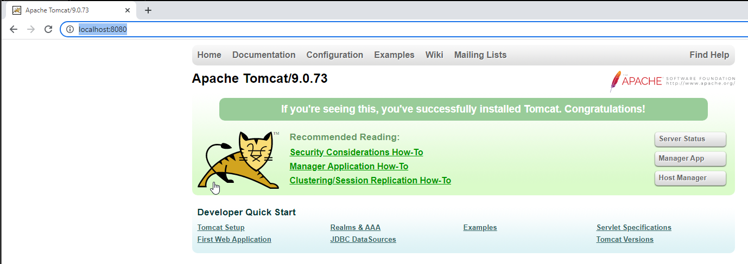

**Steps To Enable HTTPS SSL on Tomcat:**

1. Stop Tomcat service.

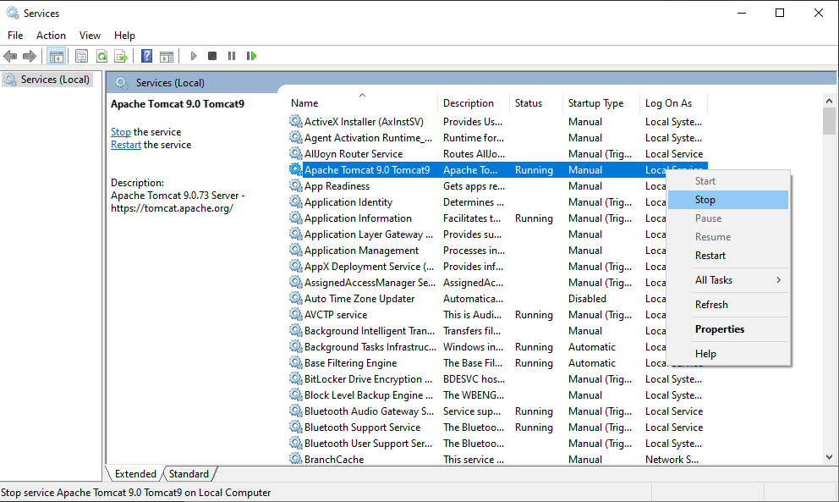

1. Open CMD and run it as Administrator.

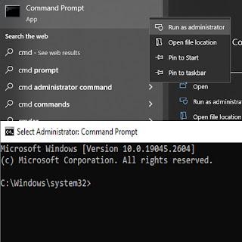

1. Go to your OpenJDK or JRE folder. Example like below.

|  |
| --- |
| cd C:\jdk-19.0.2\bin |

1. Generate a self signed certificate.

|  |
| --- |
| keytool -genkey -alias tomcat -keyalg RSA -validity 8888 -ext san=ip:127.0.0.1 -keystore "C:\localhost.jks" |

1. Specify password. Please make sure that you remember your password or maybe you can keep it somewhere safe.

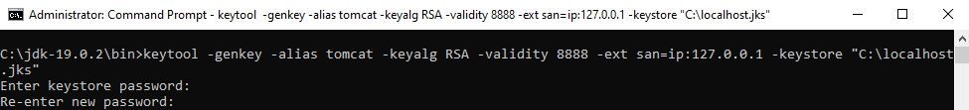

1. Specify First and last Name. Put anything you want.



1. Specify organizational unit, organization, City or Locality, State or Province, and country code. If you don't want, just keep it blank.

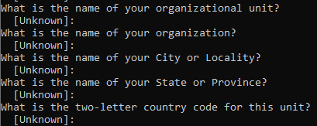

1. Specify “yes” when asked to confirm whether the information is correct.

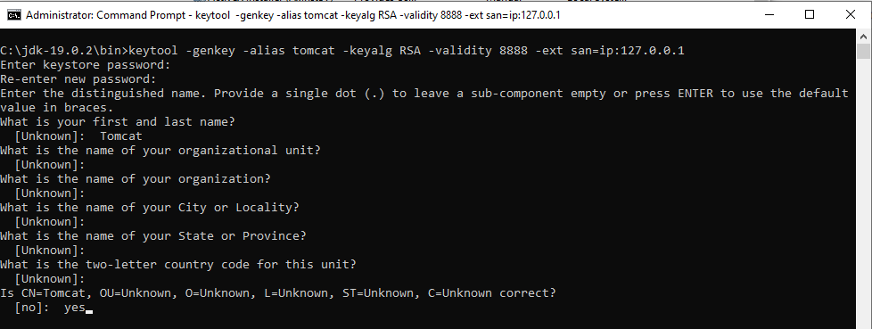

1. When prompted for key password again, just press enter. If have warning, just ignore it.



1. Go to C:\ and you will see localhost.jks the keystore you generated previously.

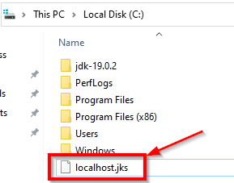

1. Move the keystore to "C:\Program Files\Apache Software Foundation\Tomcat 9.0\conf".

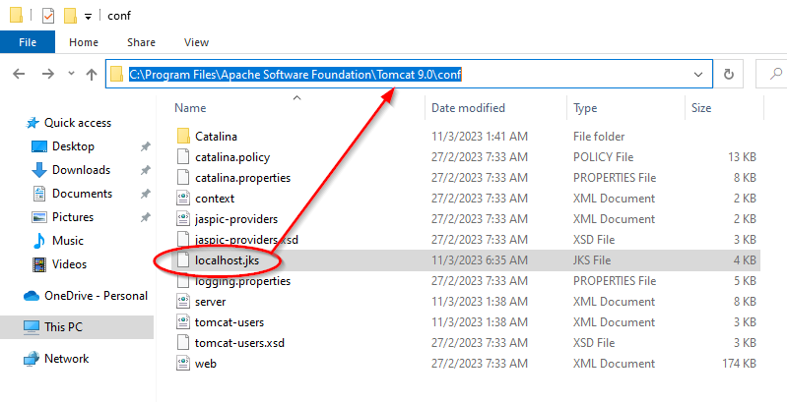

1. Now at the folder "C:\Program Files\Apache Software Foundation\Tomcat 9.0\conf", open and edit server.xml.

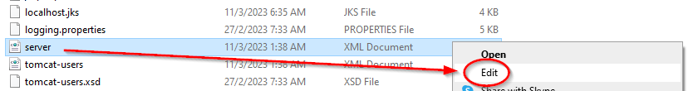

1. Search for :8080 line and add new line under it to enable HTTPS. You can copy the commands provided below in the text box to put it in the new line.

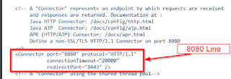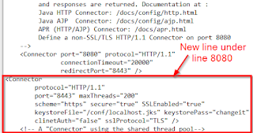

|  |
| --- |
| <Connector  protocol="HTTP/1.1"  port="8443" maxThreads="200"  scheme="https" secure="true" SSLEnabled="true"  keystoreFile="/conf/localhost.jks" keystorePass="changeit"  clinetAuth="false" sslProtocol="TLS" /> |

1. Before that, above command need to change the password with what you put previously at number 5.

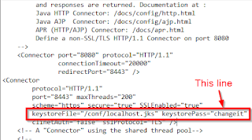

1. Restart tomcat.
2. Access tomcat web interface using browser.

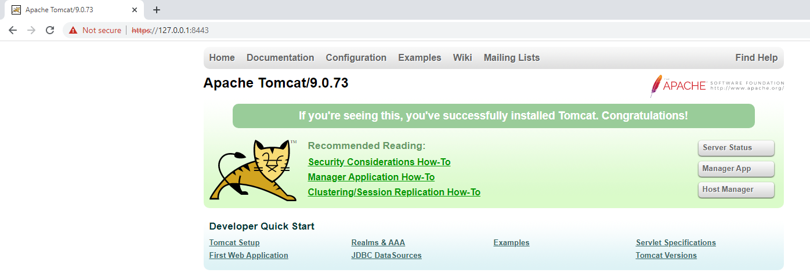

|  |
| --- |
| <https://localhost:8443> or https://SERVER_IP:8443 |